EXP 11:
AIM:
To find number of ways a ball exits grid in N steps
PROGRAM:
def find_paths(m, n, N, i, j):
dp = [[[0] * n for _ in range(m)] for _ in range(N + 1)]
directions = [(-1, 0), (1, 0), (0, -1), (0, 1)]

for step in range(1, N + 1):
for r in range(m):
for c in range(n):
for dr, dc in directions:
nr, nc = r + dr, c + dc
if nr < 0 or nr >= m or nc < 0 or nc >= n:
dp[step][r][c] += 1
else:
dp[step][r][c] += dp[step - 1][nr][nc]

return dp[N][i][j]

m, n, N, i, j = 2, 2, 2, 0, 0
print("Output:", find_paths(m, n, N, i, j))

m, n, N, i, j = 1, 3, 3, 0, 1
print("Output:", find_paths(m, n, N, i, j)

OUTPUT: 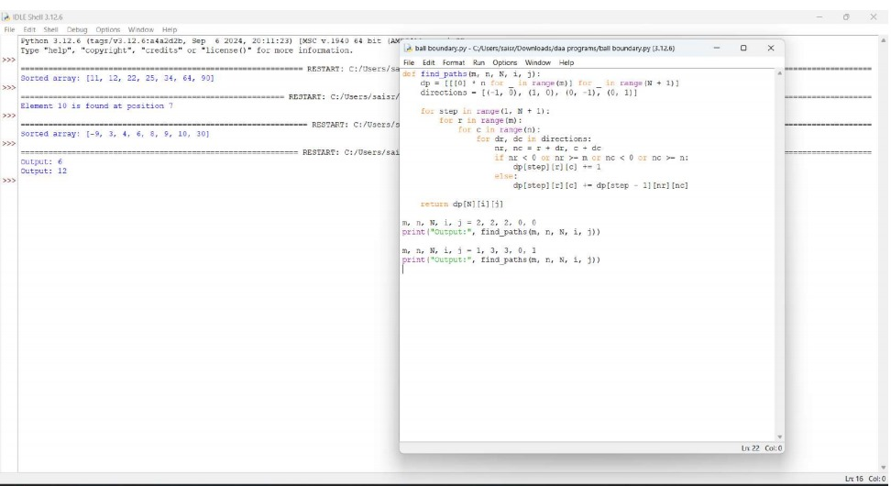

EXP 12:
AIM:
To find maximum money without robbing adjacent houses in a circle
PROGRAM:
def rob(nums):
if not nums:
return 0
if len(nums) == 1:
return nums[0]

def simple_rob(arr):
prev, curr = 0, 0
for num in arr:
prev, curr = curr, max(curr, prev + num)
return curr

return max(simple_rob(nums[:-1]), simple_rob(nums[1:]))

nums = [2, 3, 2]
print("The maximum money you can rob without alerting the police is", rob(nums))
OUTPUT: 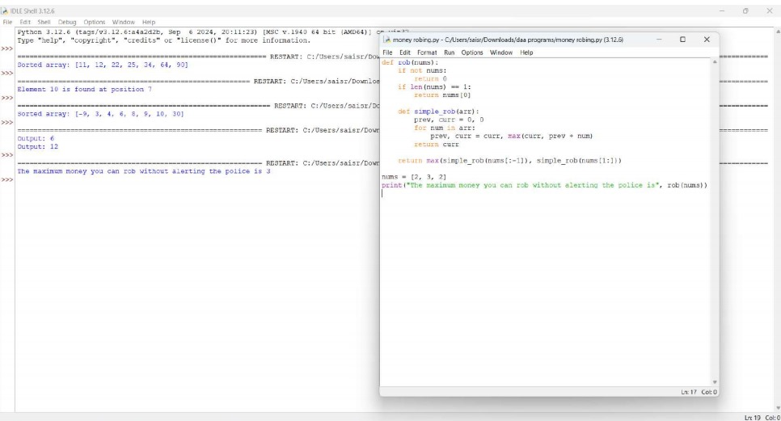

EXP 13:
AIM:
To count distinct ways to climb stairs using 1 or 2 steps
PROGRAM:
def climb_stairs(n):
if n <= 2:
return n

prev, curr = 1, 2
for _ in range(3, n + 1):
prev, curr = curr, prev + curr
return curr
n = 4
print("The number of distinct ways to climb to the top is", climb_stairs(n))
n = 3
print("The number of distinct ways to climb to the top is", climb_stairs(n))
OUTPPUT:
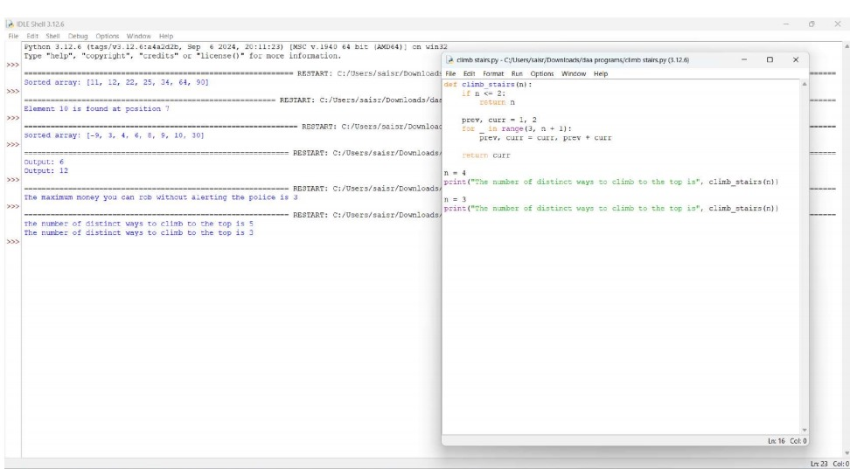
EXP 14:
AIM:
To find number of ways robot reaches bottom-right
PROGRAM:
def unique_paths(m, n):
dp = [[1] * n for _ in range(m)]

for i in range(1, m):
for j in range(1, n):
dp[i][j] = dp[i - 1][j] + dp[i][j - 1]

return dp[m - 1][n - 1]

m, n = 7, 3
print("The number of unique paths is", unique_paths(m, n))

m, n = 3, 2
print("The number of unique paths is", unique_paths(m, n))
OUTPUT: 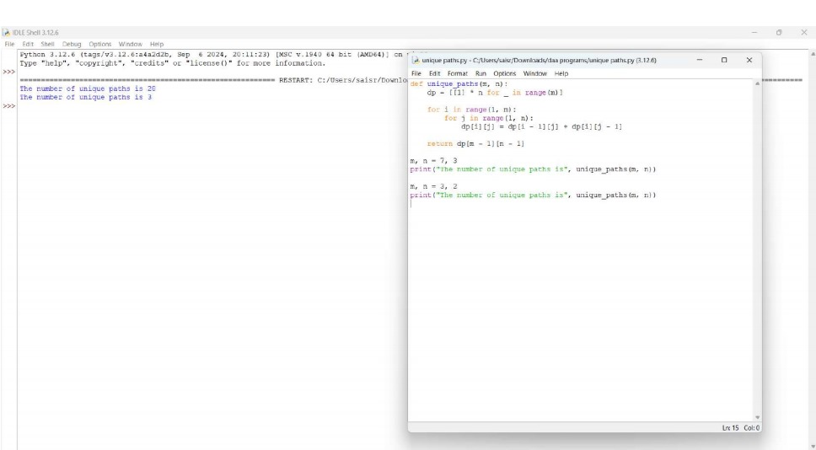
EXP 15:
AIM:
To find intervals with >=3 repeating characters.
PROGRAM:
def large_group_positions(s):
result = []
i = 0
while i < len(s):
j = i
while j < len(s) and s[j] == s[i]:
j += 1
if j - i >= 3:
result.append([i, j - 1])
i = j
return result
s = "abbxxxxzzy"
print("Large group positions:", large_group_positions(s))
OUTPUT: 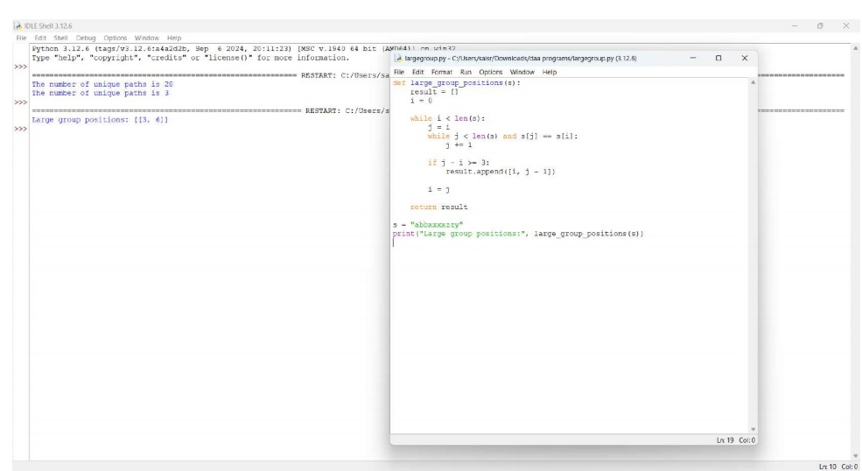

EXP 16:
AIM:
To generate next state of board based on rules.
PROGRAM:
def game_of_life(board):
m, n = len(board), len(board[0])
directions = [(-1, -1), (-1, 0), (-1, 1), (0, -1), (0, 1), (1, -1), (1, 0), (1, 1)]

def count_live_neighbors(r, c):
count = 0
for dr, dc in directions:
nr, nc = r + dr, c + dc
if 0 <= nr < m and 0 <= nc < n and abs(board[nr][nc]) == 1:
count += 1
return count

for i in range(m):
for j in range(n):
live_neighbors = count_live_neighbors(i, j)
if board[i][j] == 1 and (live_neighbors < 2 or live_neighbors > 3):
board[i][j] = -1
elif board[i][j] == 0 and live_neighbors == 3:
board[i][j] = 2

for i in range(m):
for j in range(n):
if board[i][j] == -1:
board[i][j] = 0
elif board[i][j] == 2:
board[i][j] = 1

return board

board = [[0,1,0],[0,0,1],[1,1,1],[0,0,0]]
print("Next state:", game_of_life(board))
OUTPUT:
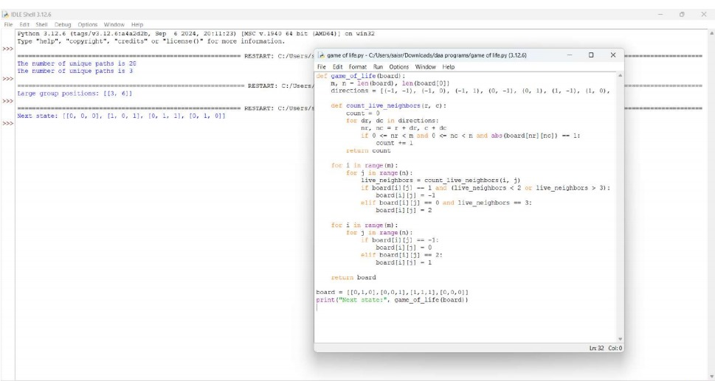

EXP 17:
AIM:
To determine how full a specific glass is after pouring.
PROGRAM:
def champagne_tower(poured, query_row, query_glass):
tower = [[0] * (i + 1) for i in range(101)]
tower[0][0] = poured

for row in range(100):
for col in range(row + 1):
overflow = (tower[row][col] - 1.0) / 2.0
if overflow > 0:
tower[row + 1][col] += overflow
tower[row + 1][col + 1] += overflow

return min(1, tower[query_row][query_glass])

poured, query_row, query_glass = 1, 1, 1
print("Champagne in glass:", champagne_tower(poured, query_row, query_glass))
OUTPUT: 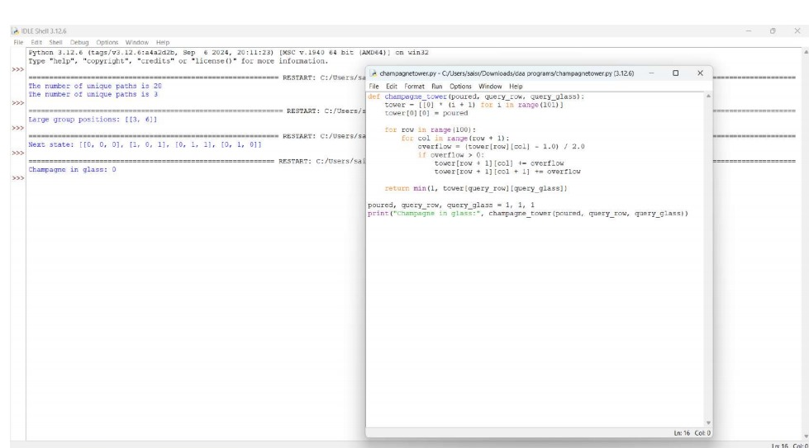

EXP 18:
AIM: To implement a function that returns the input list unchanged.
PROGRAM:
def process_list(lst):
return lst
test_cases = [
[7, 7, 7, 7],
[-3, -5, -7]
]
for i, inp in enumerate(test_cases, 1):
print(f"Test Case {i}: Input: {inp} | Output: {process_list(inp)}")
OUTPUT:
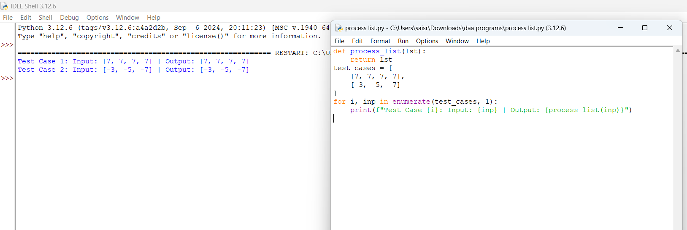
EXP 19:
AIM:To describe the Selection Sort algorithm's process of sorting an array and explain its simplicity and inefficiency, along with step-by-step examples of sorting different types of arrays.
PROGRAM:
def selection_sort(arr):
n = len(arr)
for i in range(n):
min_index = i
for j in range(i + 1, n):
if arr[j] < arr[min_index]:
min_index = j
arr[i], arr[min_index] = arr[min_index], arr[i]
return arr

test_cases = [
[5, 2, 9, 1, 5, 6],
]

for i, inp in enumerate(test_cases, 1):
print(f"Test Case {i}: Input: {inp} | Output: {selection_sort(inp)}")
OUTPUT:
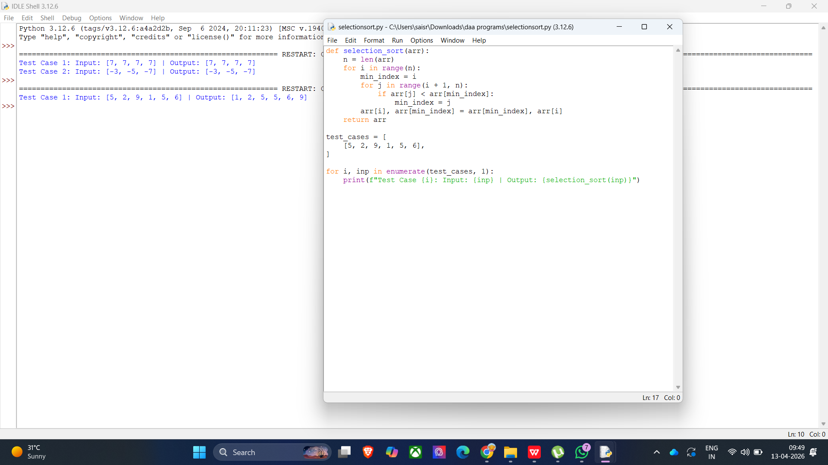
EXP 20:
AIM:To modify the Bubble Sort algorithm to stop early if the list becomes sorted before all passes are completed and test it with various input scenarios.
PROGRAM:
def bubble_sort(arr):
n = len(arr)
for i in range(n):
swapped = False
for j in range(0, n - i - 1):
if arr[j] > arr[j + 1]:
arr[j], arr[j + 1] = arr[j + 1], arr[j]
swapped = True
if not swapped:
break
return arr

test_cases = [
[64, 25, 12, 22, 11],
]

for i, case in enumerate(test_cases, 1):
print(f"Test Case {i}: Input: {case} | Output: {bubble_sort(case)}")
OUTPUT:
